

**Adobe Acrobat DC**

Adobe Acrobat DC, also known as Adobe Document Cloud, is a subscription software application developed by Adobe Inc. to create, view and print PDF files. This software is mostly used by companies that deals with contracts regularly with staff ranging between 50 or more employees.

Adobe Acrobat DC comes in 2 versions, Standard and Pro. The Standard version is a free software for personal use as a PDF viewer to print or annotate PDFs while the Pro version includes the functions in Standard along with Adobe Document Cloud services, PDF editing functionalities, and early access to future updates. The Pro version can be paid monthly or annually for RM117.66/month or RM70.64/month respectively. Adobe Acrobat DC has built-in optical character recognition (OCR) system that allows PDF files to be converted into editable and searchable document. It also allows user to sign legal electronic and digital signatures on documents and deliver them from any device. Besides viewing and printing PDFs, it can also rearrange PDF pages, combine PDFs, and compress it into smaller file in size. This software also includes Adobe Document Cloud services to store or access files from cloud storage, enabling workflow for e-signing and sending documents, and keep track of documents in real-time. Adobe Acrobat DC allows some security functions such as enabling password protection, remove hidden information in documents and PDF encryption.

In conclusion, Adobe Acrobat DC is a solid PDF editing software for personal or organizational use on PDF documents.

(243 words)

# Illustration

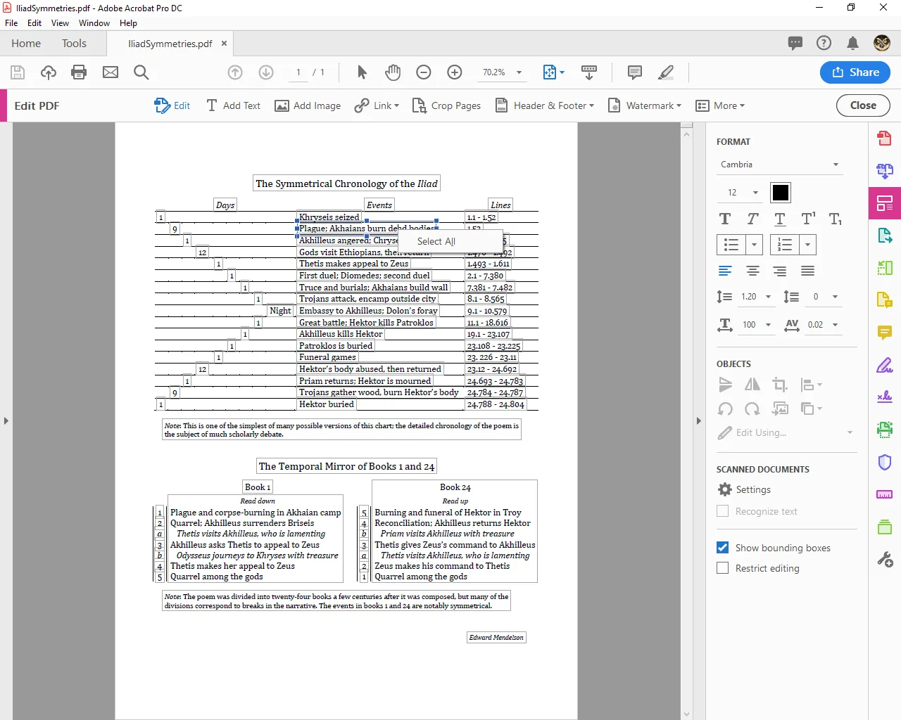

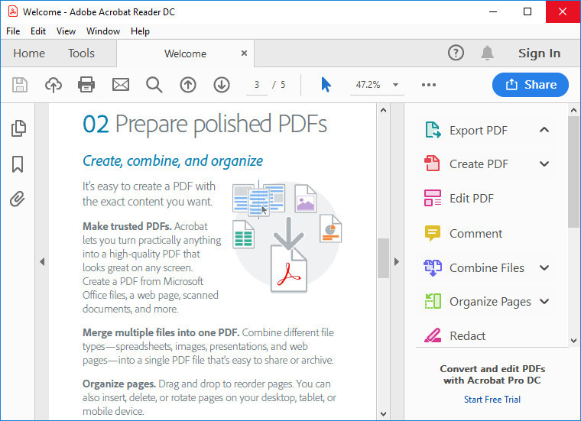

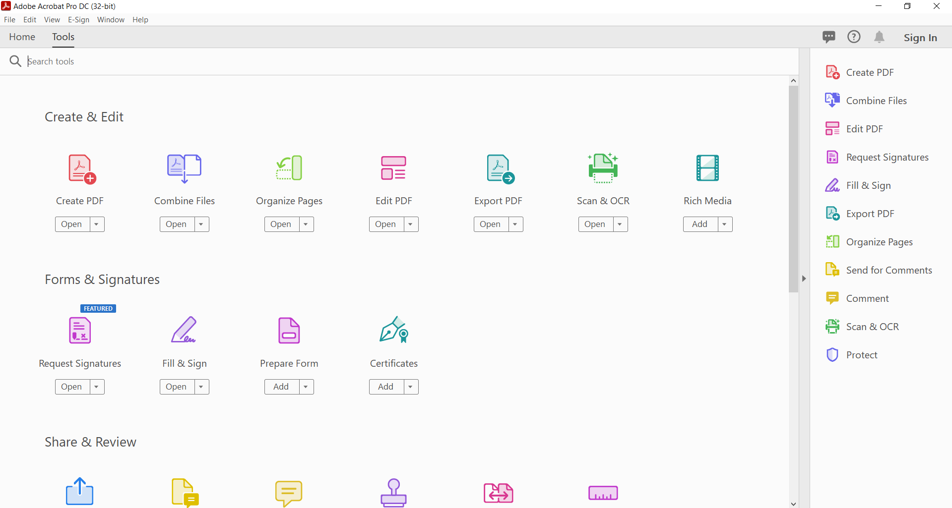

# References

* <https://enlyft.com/tech/products/adobe-acrobat-pro>
* <https://en.wikipedia.org/wiki/Adobe_Acrobat>
* <https://www.adobe.com/acrobat/pricing.html>
* <https://www.quora.com/Is-Acrobat-DC-the-same-as-Acrobat-Pro>
* <https://www.pcworld.com/article/397929/adobe-acrobat-standard-dc-vs-adobe-acrobat-pro-dc.html>